**IMPORTING THE MODEL BUILDING LIBRARIES**

Import the libraries that are required to initialize the neural network layer, create and add different layers to the neural network model.

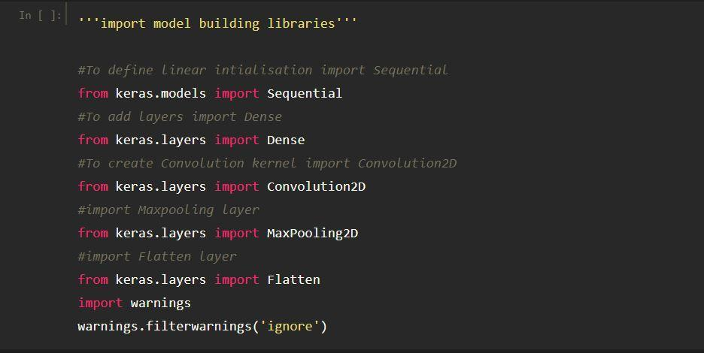

Keras is a library that is designed specifically for developing the neural networks for ML models. It can run on top of Theano and TensorFlow to train neural networks.

It is based on two fundamental Python libraries, NumPy and SciPy. Most supervised and unsupervised learning algorithms are supported by Scikit-learn.

Scikit-learn may also be used for data mining and analysis, making it a great tool for those who are just getting started with machine learning.

AI, in particular, is a way of using neural networks for machine learning. A neural network is probably a concept older than machine learning. Unsurprisingly, there were many libraries created for it.